

Content Idea Generation

Aim & Scope  Guide SEO writers and strategists in identifying high-quality, data-driven content ideas for inclusion in the content strategy template. | Background  This guide combines multiple data sources to ensure content ideas are both strategically aligned and search-optimised. It draws insights from client offerings, search demand analysis, Google Search Console performance data, and Ahrefs keyword rankings.

Responsibilities

Project Manager  Analyses data sources and drafts initial content ideas based on strategic fit and opportunities. Takes approved content ideas, creates briefs and schedules tasks in Asana | SEO Copywriter  Executes by writing the actual content. | Reviewer  Verifies that each idea meets quality, intent, and search demand criteria.
Prerequisites & TOC

Table of contents:  Content Idea Generation  Keyword Research from Scratch (Using Client Inputs + Ahrefs)  Find opportunities for optimisation and content ideas using Google Search Console  Find opportunities for optimisation and content ideas using Ahrefs rankings  Find opportunities for optimisation and content ideas using the SEOSurfer topic research feature | Links:  - Content strategy + ideation template  - Content Strategy Population  - Keyword research for content creation  - Keyword research sheet - template  - Surfer logins  - Ahrefs logins  - Tools required: Ahrefs, Google Search Console, Keyword Research Template, SurferSEO  - If a content audit has been completed, use it.

Keyword Research from Scratch (Using Client Inputs + Ahrefs)
Use this approach when:
- Creating new content ideas (e.g. blog posts, landing pages, guides)
- Building a content cluster around a product or service
- Identifying early-stage or evergreen opportunities related to a client’s offering

Step 1: Review Client Materials and Identify Core Themes
Start by understanding the client’s offering and the goals behind content creation.

Look for:
- Core products/services
- Key features or selling points
- Audience segments and search intent
- Business goals (e.g. sell more units, educate customers, rank above competitors)

Example:
Let’s say the client sells coffee machines via an e-commerce store. Key content themes might include:
- Product types: espresso machines, filter coffee makers, bean-to-cup, capsule-based, French press
- Use cases: small kitchens, office use, travel, single-serve, family-sized
- Buyer motivations: ease of use, programmability, aesthetics, price
- Customer intent: buying guides, comparisons, how-tos, reviews, product pages
These themes become the foundation for your keyword brainstorming.

Build Your Brainstorm List in the Keyword Research Template
Tip: Refer to the keyword research for content creation SOP for a more detailed list of steps and processes to follow.
In your keyword research sheet, use the brainstorm tab to generate keyword combinations.
- Column A: Modifiers like “best”, “cheap”, “programmable”, “for home”, “with grinder”
- Row 1: Base terms like “coffee maker”, “coffee machine”, “espresso machine”
The sheet will auto-generate combinations such as:
- “best coffee maker”
- “coffee machine for home”
- “cheap espresso machine with grinder”
Use the FLATTEN formula to consolidate these into one column, which you will copy and paste into Ahrefs.

Export Data from Ahrefs
- Go to Ahrefs Keywords Explorer
- Paste your flattened list into the search bar
- Choose your target location (e.g. United States)
- Click ‘Search’
- Export the following tabs:
  - Overview
  - Matching Terms
  - Questions
  - Related
  - SERP for 1–2 core terms
Click Export and download it as CSV and *store it in your keyword research sheet.
*Click File -> Import -> Navigate to Upload -> Drag and drop your CSV -> Under Import Location, select Append to Current Sheet -> Click on the green Import File button
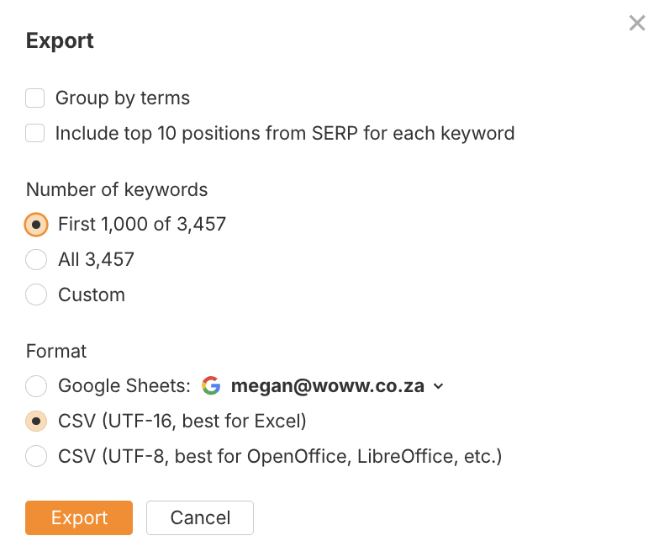

Apply Filters to Find High-Value Opportunities
Open each export and apply filters to shortlist ideas:
- Keyword Difficulty: Look for KD < 20 for quick wins
- Volume > 0: **Exclude zero-volume terms
- Modifiers: Filter by word fragments like “best”, “buy”, “how to”, “vs” to isolate intent
Your goal is to find keywords with a good balance of demand, intent match, and achievable difficulty.
**Zero-volume terms can hold value, but this is just an illustrative example.

Export SERP Data for Top Keywords
For 1–2 shortlisted terms, export the SERP overview from Ahrefs. This helps you:
- Check Domain Rating (DR) and content quality of competitors
- Understand the types of content ranking (e.g. product pages vs. listicles)
- Evaluate estimated traffic, backlinks, and keyword coverage per page
This context helps inform both feasibility and format.
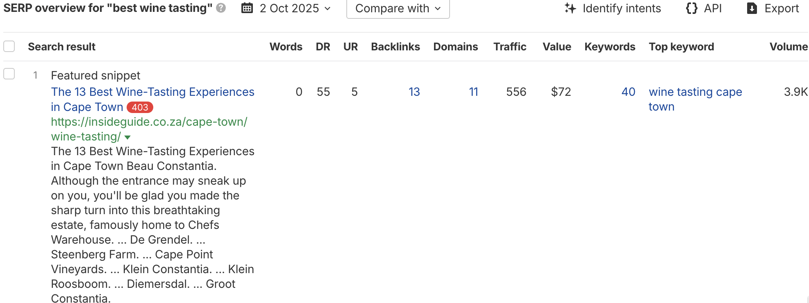

Identify and Shortlist High-Potential Content Ideas
Cross-reference your keyword data with the SERP insights to select keywords where:
- The client can match search intent
- Their site can realistically compete (based on DR, backlinks, etc.)
- There’s scope to rank for multiple related terms in one piece

Example shortlist:
Keyword | KD | Volume | Traffic Potential | Intent | Notes
best coffee machine for home | 14 | 1,100 | 4,200 | Informational/commercial | Ideal for comparison blog post
programmable coffee maker | 8 | 500 | 2,100 | Informational/commercial | Could form part of a broader buying guide
coffee machine with grinder | 12 | 800 | 3,800 | Transactional | Perfect for BOFU landing page
how to clean a coffee maker | 4 | 650 | 1,900 | Informational | Evergreen blog post with internal linking value
Based on these, you might add the following ideas to the content strategy template:
- “Best Coffee Machines for Home Use in 2024” — comparison blog for T/MOFU traffic
- “Coffee Machines with Built-in Grinders” — product-focused landing page
- “How to Clean Your Coffee Maker: Step-by-Step Guide” — evergreen article that supports SEO and post-purchase UX
- “What Is a Programmable Coffee Maker and Is It Worth It?” — supportive MOFU article for feature education
Transfer these ideas to the content strategy template and complete the fields as per the Content Strategy Population.

Mapping Keywords to Different Stages of the Funnel
Understanding where a keyword fits in the marketing funnel helps you align content with user intent. Use this structure to determine whether a keyword should drive awareness, support evaluation, or prompt a purchase. Each funnel stage requires a different type of content and strategy.

Top of the Funnel
These keywords reflect early-stage research or learning intent. People using these search terms are discovering options, exploring how things work, or seeking general guidance. Content should focus on educating the audience and building trust.

how to make iced coffee at home without machine, how to make iced coffee without machine, what is the best coffee machine, what is the best bean to cup coffee machine, how to make iced coffee with machine, how to clean a pod coffee machine, how to make iced coffee nespresso machine, how to make iced coffee without a machine, what is the best automatic coffee machine, how to clean drip coffee maker with vinegar, how to make coffee with a drip machine, how to clean drip coffee maker, what is the best jura coffee machine, how to make coffee in a drip coffee maker, how to choose the best coffee machine, what is the best coffee vending machine, how to make iced coffee espresso machine, how to put coffee pod in nespresso machine, what is the best automatic coffee machine for home, how to descale a coffee pod machine.

Middle of the Funnel
These keywords show product-aware, evaluation-stage intent. Users are comparing features, brands, or styles. Content should position the product, highlight benefits, and help readers choose the right solution.

automatic coffee machine, industrial coffee machine, best coffee machine south africa, best bean to cup coffee machine, coffee pod machine, best coffee machine, coffee machine with grinder, portable coffee maker, best bean to cup coffee machine south africa, drip coffee machine, pod coffee machine, iced coffee machine, drip coffee maker, portable coffee machine, fully automatic coffee machine, best home coffee machine, best automatic coffee machine south africa, best home coffee machine south africa, philips automatic coffee machine, coffee machine industrial

Bottom of the Funnel
These keywords indicate high purchase intent. Users are ready to take action — they’re looking for prices, locations, or where to buy. Content should prioritise calls to action, product pages, and clear conversion paths.

industrial coffee machine for sale, industrial coffee machine price, automatic coffee machine for sale, coffee machine industrial price, coffee pod machine for sale, pod coffee machine for sale, cheapest coffee pod machine, fully automatic coffee machine price, coffee pod machine cheap, cheapest fully automatic coffee machine, coffee pod machine near me, cheapest automatic coffee machine, industrial coffee machine prices, automatic coffee machine for shop, cheap pod coffee machine, portable coffee maker near me, automatic coffee machine price, buy coffee pod machine, what pod coffee machine should i buy

Find Opportunities for Optimisation and Content Ideas Using Google Search Console
Important tip: Before adding filters for specific queries and pages, export all of the data to Google Sheets, then click data > add filter and add filters to specific columns such as search volume, impressions, average position, etc.
It will be easier for you to analyse the data this way as opposed to simply using filters in Google Search Console. Use specific conditions in your filters to find opportunities.
For example, for clicks, you could set a condition for “less than 10/a small number”, for impressions, you could set a condition for “greater than 500/set an appropriate benchmark”.

1. Low CTR, High Impressions (Optimisation Opportunity)
- Sort by Impressions (descending).
- Look for queries with:
  - High impressions
  - Low average CTR (e.g. <1%)
  - Position between 5–15+
- Analyse their search intent using Ahrefs and ad hoc Google searches to determine the right content type to pursue for blogging or landing page optimisation efforts.

2. Ranking Keywords Not Included in Page Copy (Content Expansion)
- Filter by page → Click into the page → View associated queries.
- Export keyword list.
- Check for relevant keywords not currently included in the page’s on-page content.
- Action: Expand or optimise the page to include missing keywords.

3. Queries With Good Clicks but Low Average Position (Rank Boosting)
- Filter queries with CTR > 2% but average position worse than 15.
- Action: Target these keywords with supporting content or internal linking.

4. Discover New Content Ideas From Query Data
- Switch to the “Queries” tab.
- Sort by Impressions.
- Identify high-volume informational or long-tail queries not yet addressed in your blog or content plan.
- Action: Add to content idea list for new blog posts, guides, or landing pages.
Use the Export function (top-right of the report) → Export to Sheets or CSV.

5. Clean and Categorise:
- Informational or commercial queries → Blog content (how does x work, what is x, best x in South Africa)
- Transactional queries → Landing page optimisations
- Navigational queries → UX/site structure review

Find Opportunities for Optimisation and Content Ideas Using Ahrefs Rankings

1. Boost Keywords Ranking #4–#10 (Quick Wins)
- Filter keywords by position 4–10.
- Prioritise high-volume, low-KD keywords.
- Action: Refresh page, improve internal links, re-optimise copy.

2. Find Declining Pages Using “Top Pages” Report
- Go to Top Pages under Organic Search.
- Sort by traffic decline (click “↓” arrow on the traffic column twice).
- Action: Refresh outdated content, update year mentions, re-check search intent.

3. Unintentionally Ranking Keywords
- Use Organic Keywords → filter for low position (e.g. 11–30).
- These might not be the main target of the page.
- Action: Consider spinning out a new article targeting the keyword specifically.

4. Cluster Keywords by URL for New Supporting Pages
- Export keyword list by URL.
- If a single URL is ranking for 10–15 diverse keywords with varied intent, break into:
  - A main pillar page
  - Multiple supporting blog posts
- Action: Add supporting pages to your content strategy.

5. Use the “Content Gap” Tool for Competitive Opportunity
- Navigate to Content Gap
- Add 2–3 competitors.
- Identify keywords your competitors rank for that you don’t.
- Action: Use these insights to generate new blog ideas or landing pages.

6. Exporting & Organising
- Use the Export feature to download relevant keyword lists by page or report.
- Add specific pieces of data to the content ideation sheet (for example, related keywords that you can include in the page more often, or if there’s a new keyword that you can target with a blog post or landing page).
- The focus should be to categorise the opportunities by whether you should:
  - Optimise existing content
  - Create new content (blog/landing page)
  - Rework/update decaying content

Find Opportunities for Optimisation and Content Ideas Using the SEOSurfer Topic Research Feature

When to Use the Topical Map Option
Best for:
New websites or expanding into completely new content territories, and your domain is at the start or closer to the start of its journey.
Use it When:
- You’re launching a new website or blog and need a full topical foundation.
- You’re moving into a new industry or product category that your site hasn’t covered yet.
- You want to build topical authority from scratch and understand what it takes to compete.
- You’re doing a large-scale content strategy and want to map out all necessary topics for the long term.
- You want a complete blueprint of what to cover to rank in a niche.
How it Works:
- Uses your seed keyword and country/language settings to explore all possible related content clusters.
- Generates a wide, unbiased map of what Google considers topically relevant—even if your domain doesn’t currently rank for it.
- Prioritises topical coverage over domain-specific opportunities.
Example Use Case:
A health brand expanding into “functional superfoods” could use the Topical Map to explore and plan content around “moringa, “

Setup Steps

Open Topical Map Tool
- Go to Tools → Topic Research → New Topic Research
- Enter a broad seed keyword (e.g. “sustainable skincare”, “dog training”, “espresso machines”).
- Choose your target region/language.
Generate the Topical Map
- Surfer will crawl SERPs for your seed keyword and build a topical hierarchy of primary topics, subtopics, and suggested article ideas.
- Each idea is based on actual search data, semantic relationships, and competitive analysis.
Connect Your Domain
- Once Surfer has generated the topic clusters, connect your domain using Google Search Console.
Review the Topic Clusters
- Review how Surfer has organised the content ideas (pillar + supporting posts).
- Each node includes keyword intent, volume, and competition data.
Export and Strategise
- Export the entire topical map into CSV or use it to:
  - Plan pillar/supporting content structures
  - Build clusters and internal linking strategies
  - Brief out articles using the Content Editor integration
Apply Filters (Optional)
- Use filters like intent, keyword difficulty, or search volume to prioritise specific content ideas (e.g. quick wins or high-opportunity clusters).
Check Out These Examples for Baobest:
- Baobab powder - seed keyword
- Baobab oil - seed keyword
  - Using these maps, we decided to create a series of comparison articles that compare baobab powder to established superfruit powders.
  - The same for baobab oil vs other more established seed oils.

When to Use the Domain Map Option
Best for:
Domains that already have some content and are ranking in the niche (even modestly).
Use it When:
- Your domain has existing topical authority or ranking content in the industry.
- You want to expand into adjacent niches or strengthen weak topic clusters.
- You’ve already published content but want to identify gaps in topical coverage.
- You need to reinforce topical authority by filling in content gaps around strong-performing pages.
- You want to use internal linking and topical clustering to build content depth around existing strong pages.
How it Works:
- Pulls in data from your Google Search Console and existing indexed pages.
- Identifies relevant subtopics you’re not ranking well for yet, but could own with strategic content.
- Prioritises topics that are semantically related to your current rankings and aligned with your domain’s strengths.

Example Use Case:
A coffee ecommerce site already ranking for “espresso machines” could use the Domain Map to build clusters around “cleaning tips,” “latte recipes,” or “grinder maintenance”—relevant to the core topic and within reach.

Setup Steps
Connect Google Search Console (GSC)
- Go to “sites”
- Click on configure for the relevant domain property/URL (i.e for All Office there are 5 options - https://www. Is the correct variation to configure)
- Select the region and language (if South Africa is the region, then “South Africa - EN” is correct).
- Navigate to the topical map (the 4th menu item below the dashboard).
Generate the Domain Map
- Surfer will pull your ranking data from GSC.
- It will analyse your domain’s topical coverage and cluster keywords/pages into themes based on what you already rank for.
Explore Your Current Topic Coverage
- Review the existing clusters that Surfer associates with your domain.
- Identify:
  - Strong topical areas (reinforce with more internal links or related articles)
  - Weak or underserved clusters (expand coverage with supportive content)
Prioritise Expansion Opportunities
- Use the data to plan content that strengthens your topical authority in semi-covered clusters.
- Export or send relevant clusters into the Content Editor or Strategy Plan.

